**A captivating memoir of a trailblazing female firefighter**

“In this evocative account of life in the firehouse, Clare Frank portrays the risks firefighters face and the stakes that are now higher than they’ve ever been. She does so with grit and a healthy sense of humor. A must-read.” **—Erin Brockovich**

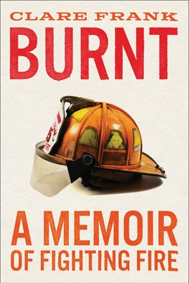

**BURNT**

***A Memoir of Fighting Fire***

**By Clare Frank**

**\*On sale: May 23, 2023\***

When Clare Frank was 17 years old, she became a firefighter in Northern California. Clare was five foot two and too young to officially join the service—she left her birthdate blank on her paperwork, hoping no one would notice. And she didn’t look like her peers, who sported an Adam’s apple and a mustache. But her brother was a firefighter and loved it, so she thought she’d try it out, too. Very soon, she knew she’d found her calling.  
        
***Burnt: A Memoir of Fighting Fire*** **(Abrams Press; May 23, 2023; $27.00; Hardcover)** is Clare’s inspiring, richly detailed, and open-hearted account of an extraordinary life in fire. It chronicles the transformation of a young adult determined to prove her mettle into a scarred and sensitive veteran, grappling with the weight of her duties as Chief of Fire Prevention—one of the highest-ranking women in Cal Fire history—while record-setting fires engulf her home state. Mentors and managing, funerals and scandal, pickup basketball, car crashes, and always fire—no one has written about this world, from this perspective, like Clare Frank. She masterfully mixes irreverence and awe, taking readers inside station houses, on daily calls, and along on wildfire campaigns where antics and dark humor balance terrifying risk, trauma, and a sense of almost holy responsibility. ***Burnt*** is an unforgettable memoir from an American original.

“Ominous orange skies and smoke-choked cities: The wildfire crisis is here. *Burnt* takes you inside. From dirt firefighter to leading thousands, Clare Frank offers a real, humorous, one-of-a-kind front-row seat to wildfires and those who fight them.”

**—Caroline Godkin, Executive Director of the Climate and Wildfire Institute**

(*Continued*)

“*Burnt* is part fire story, part family saga, part diary of a woman rising in a ‘man’s world,’ and it is entirely engrossing. If natural disasters, especially wildfires, are to reshape both where and how we live, then we had better listen to the stories of the people who fight them and the price they pay. This is one of those stories and it’s damn good.”

**—Kevin Hazzard, author of *American Sirens* and *A Thousand Naked Strangers***

“Frank is scrappy and courageous, wise and vulnerable—a serious badass with a reverence for fire, an irreverent sense of humor, and a mouth that strings together swear words with the best of them. As Frank shatters glass ceilings of the fire world ranks, you will be laughing out loud at firehouse antics, crying on heartbreaking calls, sitting on the edge of your seat during harrowing adventures, and cheering her on as she finds kinship, joy, and a greater sense of herself within this unconventional calling. . . This is one of the best memoirs I’ve read in a long time.”

**—Suzanne Roberts, author of *Animal Bodies: On Death, Desire, and Other Difficulties***

“*Burnt* is a wonderful reminder of how those who fall in love with the intensity and magic and deadliness of flames are always best at fighting fire . . . Frank’s writing is vivid and beautiful, and her stories of the structure of firefighting lives will resonate with those who love a great story of passion.” **—Susan Straight, author of *Mecca* and *In the Country of Women***

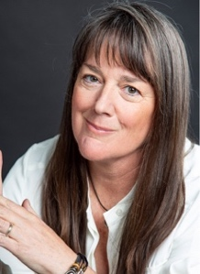

**ABOUT THE AUTHOR**

**Clare Frank** started firefighting in California at 17 and was promoted up the ranks, becoming the state’s first and only female Chief of Fire Protection. Along the way, she earned a BS in fire administration, an MFA in creative writing, and a JD. She has lectured at colleges, universities, and state and national fire conferences, and lives near Lake Tahoe with her husband and two dogs. This is her first book.

**ABOUT THE BOOK**

**Burnt: A Memoir of Fighting Fire**

By Clare Frank

Abrams Press / May 2023

U.S. $27.00 / CAN $34.00 / UK £18.99

Hardcover with jacket / 336 pages / 6 x 9"

ISBN: 978-1-4197-6390-8

Also available as an e-book

Founded in 1949, ABRAMS was the first company in the United States to specialize in publishing art and illustrated books. The company continues to publish critically acclaimed and bestselling works in the areas of art, photography, cooking, craft, comics, interior and garden design, entertainment, fashion, and popular culture as well as narrative non-fiction and new works of fiction for adults; children’s books ranging from middle grade to young adult fiction to picture books to board books. ABRAMS creates and distributes brilliantly designed books with the highest production values under the following imprints: Abrams; Abrams ComicArts; Megascope; Surely Books; Abrams Image; Abrams Press; The Overlook Press; Cernunnos; Cameron + Company; Abrams Books for Young Readers; Amulet Books; Abrams Appleseed; and Magic Cat. ABRAMS also distributes books for Booth-Clibborn Editions, Bungie, Alain Ducasse Édition, Èditions de La Martiniére, Editions BPI, Global Golf Group, Lucky Spool, Milky Way Picture Books, The Museum of Modern Art, SelfMadeHero, Tate Publishing, V&A Publishing, and The Vendome Press.